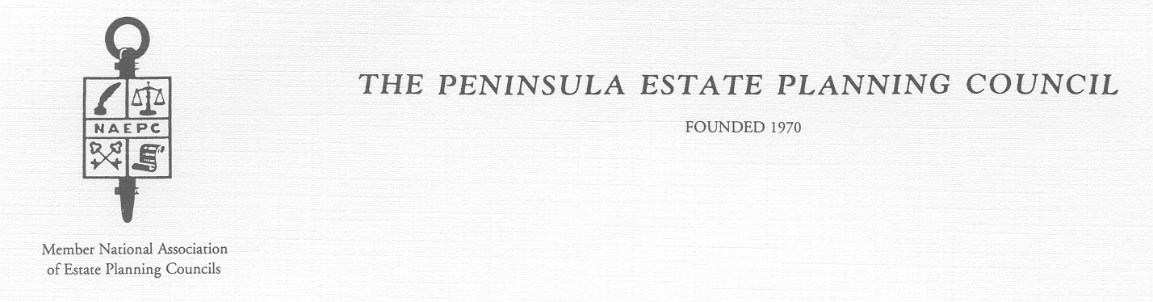

OFFICERS – 2009-2010 EXECUTIVE COMMITTEE

John T. Hart, CPA Richard L. Ferris, Attorney
President Ed Rock, CLU
Patrick B. McDermott, Attorney Rob Carmines, CPA
1st Vice President Robert T. Cowling, CLU/Trust Officer
Paul Roa, CLU Immediate Past President
2nd Vice President
Martha Madeira, Trust Officer
Treasurer
Jeremy Johnson, Attorney
Secretary

2009-2010 MEETING SCHEDULE AND DUES NOTICE

Dinner Meeting Schedule:
October 6, 2009 February 2, 2010
December 1, 2009 May 4, 2010

Dues Notice

Dues are payable upon receipt of this notice. The 2009-2010 dues are $175.00 per member, if paid by December 1, 2009.

After December 1, 2009 the dues will be $225.00.

Guest fees will be $40.00 per meeting.

Please send payment to:

The Peninsula Estate Planning Council
c/o Martha Madeira, Treasurer
P.O. Box 12035
Newport News, VA 23612

Thank you for your prompt attention.

