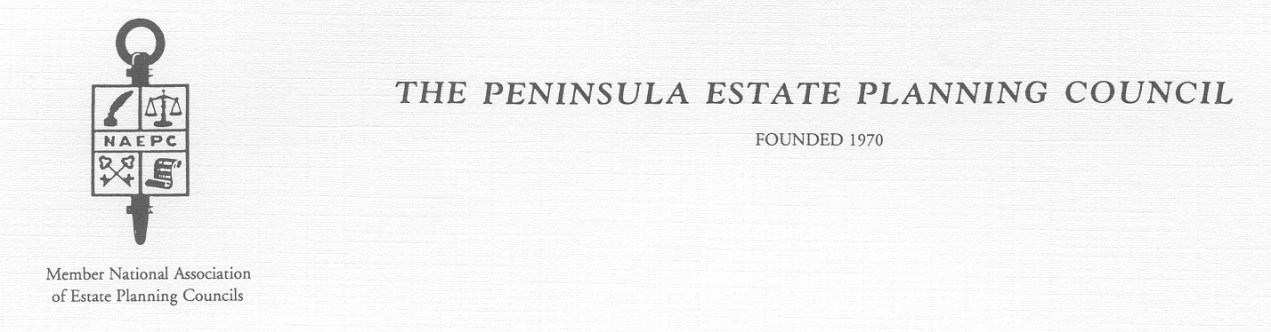

OFFICERS – 2004-2005 EXECUTIVE COMMITTEE

Anne S. Haggett, CFP Martha Madeira, Trust Officer
President
Robert T. Cowling, CLU/Trust Officer Paul Roa, CLU
1st Vice President
John T. Hart, CPA Michael Haigh, CPA
2nd Vice President
Patrick B. McDermott, Attorney Gregory Lawson, CPA
Treasurer Past President

2007-2008 DUES NOTICE

Dues are payable upon receipt of this notice. The 2007-2008 dues are $125.00 per member, if paid by December 4, 2007.

After December 4, 2007 the dues are $150.00.

Please send payment to:

The Peninsula Estate Planning Council
C/O Pat McDermott, Treasurer
P.O. Box 12035
Newport News, VA 23612

Thank you for your prompt attention.

